### E-Commerce

### A Project Report Submitted

**in Partial Fulfillment of the**

**Requirements**

**for the Degree of**

**MASTER OF COMPUTER APPLICATION**

### By

**Nirbhya Kaushik - 1900290149067**

**Under the Supervision of**

**Ms. Neelam Rawat**

**KIET Group of Institution, Ghaziabad**



**FACULTY OF COMPUTER APPLICATIONS**

**DR. APJ ABDUL KALAM TECHNICAL**

**UNIVERSITY LUCKNOW**

**(Formerly Uttar Pradesh Technical University, Lucknow)**

**JULY, 2021**

## CERTIFICATE

Certified that **Nirbhya Kaushik (University Roll No 1900290149067)** have carried out the project work having **E-Commerce** for Master of Computer Applications from Dr. A.P.J. Abdul Kalam Technical University (AKTU**)** (formerly UPTU), Technical University, Lucknow under my supervision. The project report embodies original work, and studies are carried out by the student himself/herself and the contents of the project report do not form the basis for the award of

any other degree to the candidate or to anybody else from this or any other University/Institution.

##### Nirbhya Kaushik University Roll No 1900290149067

This is to certify that the above statement made by the candidate is correct to the best of my knowledge.

Date:

##### Ms. Neelam Rawat Associate Professor

**Department of Computer Applications KIET Group of Institutions, Ghaziabad**

**Signature of Internal Examiner Signature of External Examiner**

**Dr. Ajay Kumar Shrivastava**

**Professor & Head,**

**Department of Computer Application**

**ACKNOWLEDGEMENT**

It is my pleasure to be indebted to various people, who directly or indirectly contributed in the development of this work and who influenced our thinking, behavior and acts during the course of study.

We are thankful to **Neelam Rawat** for his support, cooperation, and motivation provided to us during the training for constant inspiration, presence and blessings.

We would also like to thank our **H.O.D Mr. Ajay Kumar Shrivastava** for her valuable suggestions which helps us lot in completion of this project.

Lastly, we would like to thank the almighty and our parents for their moral support and friends with whom we shared our day-to-day experience and received lots of suggestions that improved our quality of work.

Nirbhya Kaushik

**ABSTRACT**

Our project is **E-Commerce** . This is a website which helps people to find and buy all type of things which are related to them . It is useful in the way that it makes an easier way to buy online. **E-Commerce** is an interactive e-commerce solution providing users with an opportunity to buy. .

In this website we have basically 2 modules. The first module includes the customer module and second module includes admin module.

The customer have to register for any enquiry related to products. The registered customer can view details of products and he/she can buy or sell the product of his/her need. He/she has to pay and will get home delivery.

The admin module contains the access of admin page on the website. The admin can change everything in the website. He have the ability to add, delete, and update any information regarding the products.

|  |  |
| --- | --- |
| **Certificate** | **ii** |
| **Acknowledgement** | **iii** |
| **Abstract** | **iv** |
| **Chapter-1 Introduction** | **8** |
| 1.1 Project Scope | 8 |
| 1.2 Hardware Used in Project | 8 |
| 1.3 Software Used in Project | 8 |
| 1.4 Project Schedule | 9 |
| 1.5 Define Activities | 9 |
| 1.6 How to Create Project Schedules | 9 |
| **Chapter-2 Technical Feasibility** | 10 |
| 2.1 Technical Feasibility | 10 |
| 2.2 Technology Description | 10 |
| 2.3 Technology Used in Project | 11 |
| **Chapter-3 Backend Design** | 12 |
| 3.1 Data Dictionary | 12 |
| 3.2 ER-Diagram | 12-13 |
| 3.3 Database Design | 13 |
| 3.4 Database Tables/Schemas | 14 |
| 3.5 Product Category Table | 15-16 |
| 3.6 Product Table | 16-20 |
| **Chapter-4 Frontend Design** | 21 |
| 4.1 Frontend Design | 21 |
| 4.2 HTML | 21 |
| 4.3 Javascript | 21 |
| 4.4 AngularJs | 21 |
| 4.5 NodeJs | 21 |
| 4.6 ReactJs | 22 |
| **Chapter-5 Report** | 23 |
| 5.1 ScreenShots | 23-31 |
| **Chapter-6 Testing** | 32 |
| 6.1 Testing Case for Login Page | 32 |
| 6.2 Functional Test Scenario For Login Page | 32 |
| 6.3 Security Test Case For Login Page | 33 |
| 6.4 General Test Case For E-Commerce Application | 34 |
| 6.5 Product buy Flow- Test Case for E-Commerce Website | 34 |
| 6.6 Seller- Product Creation Test Case | 34 |
| 6.7 User Registration Test Case | 35 |
| **Chapter-7 Limitations** | 36 |
| 7.1 Disadvantages & Limitation of E-Commerce Website | 36-37 |
| 7.2 Future Scope & Enhancement | 37 |
| 7.3 Future of E-Commerce In India | 38 |
| **Chapter-8 Conclusion** | 39 |
| **Chapter-9 Literature Review** | 40 |
| 9.1 Executable HTML | 40 |
| 9.2 Programing | 40 |
| 9.3 Computing | 40-41 |
| 9.4 Html5 | 41 |
| 9.5 Html , Css , Javascript | 41 |
| 9.6 Software Engineering | 41-42 |
| **Chapter-10 Refrences** | **43** |

List of Figures

|  |  |
| --- | --- |
| 1.1 ER-Diagrams | 13-15 |
| 1.2 DataBase Schemas | 17 |
| 1.3 Product Category | 18 |
| 1.4 Product Table | 19 |
| 1.5 Database | 20 |
| 1.6 API Integration | 23 |
| 1.7 Testing | 24-25 |
| 1.8 Swagger | 26-27 |
| 1.9 User Function | 28 |
| 1.10 Controller | 29 |
| 1. 11 Checkout | 30 |
| 1.12 My Wishlist | 31 |

**CHAPTER-1**

**INTRODUCTION**

In the 21st century, it is difficult not to have heard of the word **‘e-commerce’**. However, understanding the meaning of this very word is an entirely different story altogether.

Perhaps, when you hear the word e-commerce, you think of major retailers such as Home Depot or Walmart. You may even believe that the very word and idea is simply a reference to the thousands of websites that currently sell products and services online. These definitions are in fact, true, however, they only scratch the surface in terms of what can be learned about this industry.

E-commerce is a fast-growing and lucrative market. In 2019, online shopping reach ed global sales of 3.5 trillion US dollars. Having accounted for 14.1 percent of the total retail sales online in 2019, and projected to reach 22 percent by 2023 ( [Statista](https://www.statista.com/statistics/534123/e-commerce-share-of-retail-sales-worldwide/)), its no surprise that businesses and individuals alike are turning to this type of business model.

##### 1.1 Project Scope

Project scope is the part of project planning that involves determining and documenting a list of specific project goals, deliverables, features, functions, tasks, deadlines, and ultimately costs. In other words, it is what needs to be achieved and the work that must be done to deliver a project.

##### 1.2 Hardware Used in Project:

* + - Windows 10
    - 500 GB HDD
    - Ram 8 & above

**1.3 Software Used in Project**

* + - VS Code
    - MongoDB
    - Postman
    - Swagger-UI

**1.4 Project Schedule**

In order to develop our schedule, we first need to define the activities, sequence them in the right order, estimate the resources needed, and estimate the time it will take to complete the tasks.

**1.5 Defining Activities**

The activity definition process is a further breakdown of the work package elements of the WBS. It documents the specific activities needed to fulfill the deliverables detailed in the WBS. These activities are not the deliverables themselves but the individual units of work that must be completed to fulfill the deliverables. Activity definition uses everything we already know about the project to divide the work into activities that can be estimated. You

might want to look at all the lessons learned from similar projects your company has done to get a good idea of what you need to do on the current one**.**

Expert judgment in the form of project team members with prior experience developing project scope statements and WBS can help you define activities. If you are asked to manage a project in a new domain, you might also use experts in that particular field to help define tasks so you can understand what activities are going to be involved. You may want to create an activity list and then have the expert review it and suggest changes. Alternatively, you could involve the expert from the very beginning and ask to have an activity definition conversation with him or her before even making your first draft of the list.

##### 1.6 How to create project schedules

* Define your project goals. ...
* Identify all stakeholders. ...
* Determine your final deadline. ...
* List each step or task. ...
* Assign a team member responsible for each task. ...
* Work backward to set due dates for each task. ...
* Organize your project schedule in one tool, and share it with your team.

## CHAPTER-2

#### TECHNCAL FEASIBILITY

A technical feasibility study assesses the details of how you intend to deliver a product or service to customers. Think materials, labor, transportation, where your business will be located, and the technology that will be necessary to bring all this together..

This assessment focuses on the technical resources available to the organization. It helps organizations determine whether the technical resources meet capacity and whether the technical team is capable of converting the ideas into working systems. Technical feasibility also involves the evaluation of the hardware, software, and other technical requirements of the proposed system. As an exaggerated example, an organization wouldn’t want to try to put Star Trek’s transporters in their building—currently, this project is not technically feasible.

Technology Feasibility and Cost Analysis is performed to determine the potential

economic viability of a process or technology, and helps to identify which technologies have the greatest likelihood of economic success.

A technical feasibility study can provide relevant context to the different aspects of your project and serve as a great planning tool by providing an overhead view of how your project can evolve during the course of its development, troubleshooting and tracking the progress of your project from concept to reality

##### 2.2 TECHNOLOGY DESCRIPTION

Technology ("science of craft", from [Greek](https://en.wikipedia.org/wiki/Ancient_Greek) τέχνη, *techne*, "art, skill, cunning of hand"; and - λογία, [*-logia*](https://en.wiktionary.org/wiki/-logia)[[2]](https://en.wikipedia.org/wiki/Technology#cite_note-Liddell_1980-2)) is the sum of [techniques](https://en.wikipedia.org/wiki/Art_techniques_and_materials), [skills](https://en.wikipedia.org/wiki/Skill), [methods](https://en.wikipedia.org/wiki/Scientific_method), and [processes](https://en.wikipedia.org/wiki/Business_process) used in the production of [goods](https://en.wikipedia.org/wiki/Good_(economics)) or [services](https://en.wikipedia.org/wiki/Service_(economics)) or in the accomplishment of objectives, such as [scientific investigation](https://en.wikipedia.org/wiki/Scientific_investigation).Technology can be the [knowledge](https://en.wikipedia.org/wiki/Knowledge) of techniques, processes, and the like, or it can be embedded in [machines](https://en.wikipedia.org/wiki/Machines) to allow for operation without detailed knowledge of their workings. [Systems](https://en.wikipedia.org/wiki/System) (e.g. machines) applying technology by taking an [input](https://en.wikipedia.org/wiki/Input/output), changing it according to the system's use, and then producing an [outcome](https://en.wikipedia.org/wiki/Input/output) are referred to as technology systems or technological systems.

The [prehistoric](https://en.wikipedia.org/wiki/Prehistory) invention of shaped stone tools followed by the discovery of [how to control](https://en.wikipedia.org/wiki/Control_of_fire_by_early_humans) [fire](https://en.wikipedia.org/wiki/Control_of_fire_by_early_humans) increased sources of food. The later [Neolithic Revolution](https://en.wikipedia.org/wiki/Neolithic_Revolution) extended this, and quadrupled the sustenance available from a territory. The invention of the [wheel](https://en.wikipedia.org/wiki/Wheel) helped humans to travel in and control their environment.

Developments in historic times, including the [printing press](https://en.wikipedia.org/wiki/Printing_press), the [telephone](https://en.wikipedia.org/wiki/Telephone), and the [Internet](https://en.wikipedia.org/wiki/Internet), have lessened physical barriers to [communication](https://en.wikipedia.org/wiki/Communication) and allowed humans to interact freely on a global scale.

Technology has many effects. It has helped develop more advanced [economies](https://en.wikipedia.org/wiki/Economy) (including today's [global economy](https://en.wikipedia.org/wiki/Economic_globalization)) and has allowed the rise of a [leisure class](https://en.wikipedia.org/wiki/Conspicuous_leisure). Many technological processes produce unwanted by-products known as [pollution](https://en.wikipedia.org/wiki/Pollution) and deplete natural resources to the detriment of Earth's [environment](https://en.wikipedia.org/wiki/Natural_environment). Innovations have always influenced the [values](https://en.wikipedia.org/wiki/Value_(personal_and_cultural)) of a society and raised new questions in the [ethics of technology](https://en.wikipedia.org/wiki/Ethics_of_technology). Examples include the rise of the notion of [efficiency](https://en.wikipedia.org/wiki/Efficiency) in terms of human [productivity](https://en.wikipedia.org/wiki/Productivity), and the challenges of [bioethics](https://en.wikipedia.org/wiki/Bioethics).

##### 2.3 TECHNOLOGY USED IN PROJECT

* HTML
* CSS
* NodeJs
* MongoDB
* Java Script

**Server:** Postman/Swagger

**Database:** MongoDB

**Operating System:** Windows7/8/8.1/10

CHAPTER-3

BACKEND DESIGN

# DATA DICTIONARY

A data dictionary is a collection of the names, definitions, and attributes for data elements and models. The data in a data dictionary is the metadata about the database. These elements are then used as part of a database, research project, or information system.

Data dictionaries are used to provide detailed information about the contents of a dataset or database, such as the names of measured variables, their data types or formats, and text descriptions. A data dictionary provides a concise guide to understanding and using the data.

There are two types of data dictionaries: active and passive. An active data dictionary is tied to a specific database which makes data transference a challenge, but it updates automatically with the data management system.

A data dictionary in Software Engineering means a file or a set of files that includes

a database's metadata (hold records about other objects in the database), like data ownership, relationships of the data to another object, and some other data.

3.2 ER DIAGRAMS

An E-R model is usually the result of systematic analysis to define and describe what is important to processes in an area of a business. It does not define the business processes; it only presents a business data schema in graphical form. It is usually drawn in a graphical form as boxes ( *entities*) that are connected by lines (*relationships*) which express the associations and dependencies between entities. An ER model can also be expressed in a verbal form.

Entities may be characterized not only by relationships, but also by additional properties (*attributes*), which include identifiers called "primary keys". Diagrams created to represent attributes as well as entities and relationships may be called entity-attribute-relationship diagrams, rather than entity–relationship models.

An ER model is typically implemented as a [database](https://en.wikipedia.org/wiki/Database). In a simple relational database implementation, each row of a table represents one instance of an entity type, and each field in a table represents an attribute type. In a [relational database](https://en.wikipedia.org/wiki/Relational_database) a relationship between entities is implemented by storing the primary key of one entity as a pointer or "foreign key" in the table of another entity.

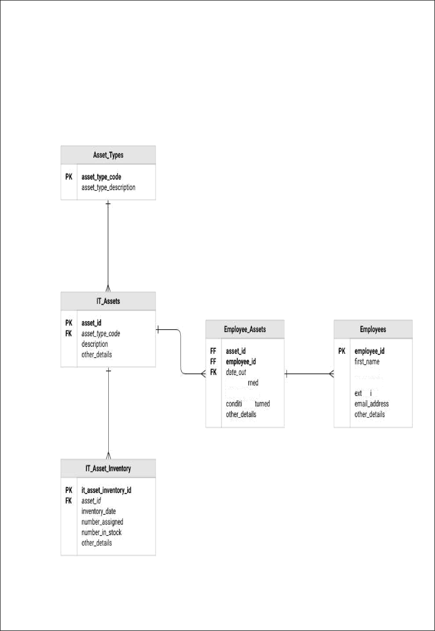

C0fl#itl0I1_0\JI

ld5LMdfllR dfl§8Flfllflh)

ffi5 00

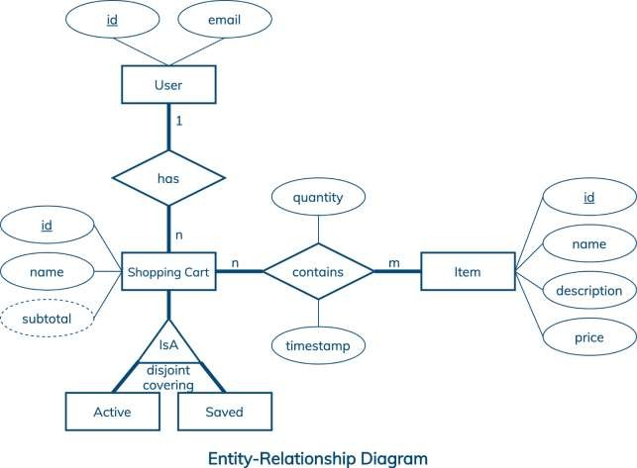

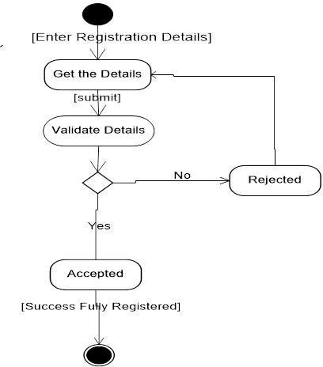

* 1. Database Design

A good e-commerce database design includes:

* Simple, functional database structure: The database table structure is simple but covers all the required functionality without compromising the user experience.
* High performance: Database queries execute quickly to facilitate live customer interactions and support a frictionless shopping experience. Therefore, the selected database should have good indexing and performance optimization options.
* High availability and scalability: A good database design is highly available with automatic snapshots and enables automatic scaling to support future platform growth as well as sudden traffic spikes.

**Based on these characteristics, good e-commerce database design involves three key parts:**

* + - Database scope: The scope refers to the planned functionality of the database. The underlying table structure of the database, its relationships, and indexes all depend on the functionality of the e-commerce platform.
    - Database type: The type can vary from a relational database to a [NoSQL database](https://resources.fabric.inc/blog/nosql-ecommerce-data-model) or a [hybrid approach](https://resources.fabric.inc/blog/sql-nosql-ecommerce) depending on the requirements and the underlying data structure.
    - Database infrastructure: Your database can be either [unmanaged or managed](https://resources.fabric.inc/blog/managed-vs-unmanaged-ecommerce). The former means spinning up your own database service; the latter means using something like Amazon RDS or Amazon DynamoDB.

The main consideration when designing the database is identifying the functionalities offered by the e-commerce platform. These functionalities can be further divided into core functions and additional functions.

Core functions are the functions necessary for facilitating the day-to-day operations of the e-commerce platform, including user management, product and inventory management, shopping cart function, payment management, and shipping/logistics management.

Additional functions are the nice-to-have functions for the e-commerce platform that enhance the user experience for both end-users (customers) and administrators(the business).

* 1. **DATABASE TABLES** /**SCHEMAS**

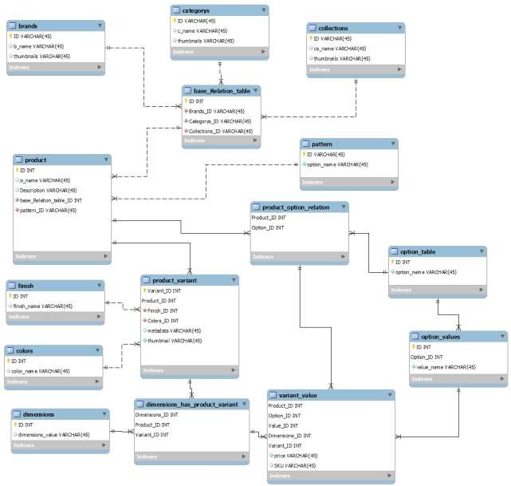

##### 3.5 Product Category Table

Product category means different types of product with different categories. See example below:

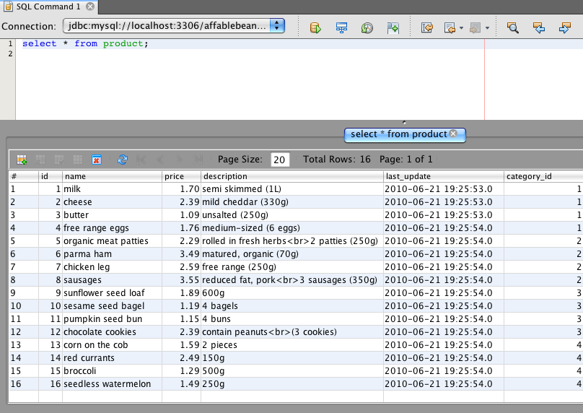

##### 3.6 Product Table

This is the most important table used in an ecommerce site because product table relates to all tables in the databaseand related fields are entered in this table like product name, price sku code etc.

Open Source which develops commerce sites are as follows:

* OpenCart
* Presta Shop
* Magento Community Edition
* Zen Cart
* Spree Commerce
* Drupal Commerce
* Os-Commerce
* Simple Cart
* WooCommerce

To Create Product Table,

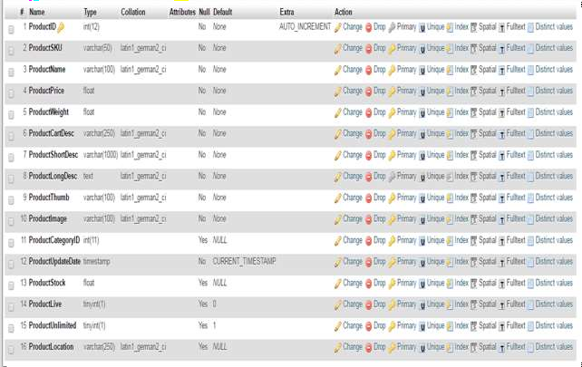

Above image shows all the product categories,



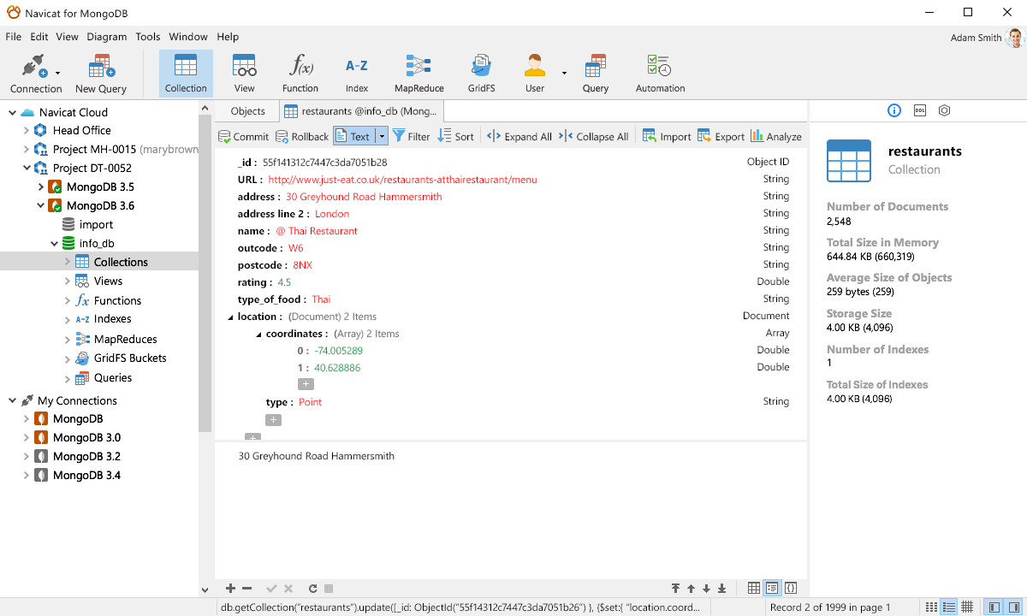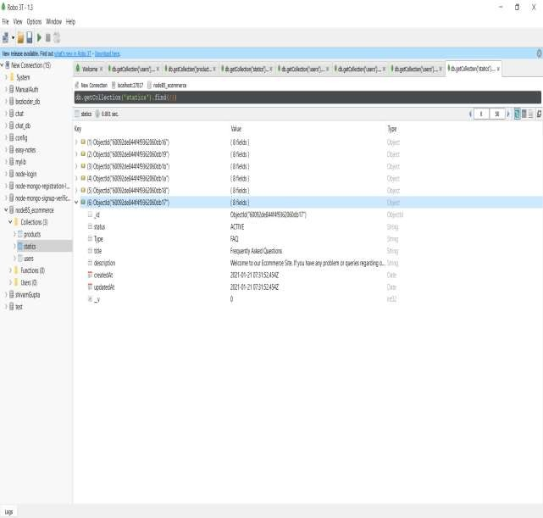

**CHAPTER-4**

**4.1 FRONTEND DESIGN**

Frontend is what appears on the user’s side most and what entices the users to give the website a stroll. Hence, the designers work at the base level of this process. The UI designer and UX engineer both works collaboratively to make the website appear at its best with less delay and amazing easy to navigate functionalities. The aim to choose the most creative and useful technologies are:

##### 4.2 HTML

HTML is probably the primary language all the developer’s expertise at the very beginning. The reason is, HTML provides building blocks to all websites, particularly text and images.

**4.3 JavaScript**

Once there is a clear understanding of HTML and the webpage skeleton, there comes the need of enriching the page with more and more content. This is the trickiest part to build a better website for ecommerce business, as we all know content is what the customers look for in the website. Hence, JS is capable of rich user experience for browser-based applications. An expert, skilled and trend-setting JS developer is a must for a ecommerce website development team.

**4.4 ReactJS**

**React** (also known as **React.js** or **ReactJS**) is an [open-source](https://en.wikipedia.org/wiki/Open-source) [front-end](https://en.wikipedia.org/wiki/Front_end_and_back_end) [JavaScript library](https://en.wikipedia.org/wiki/JavaScript_library)[[3]](https://en.wikipedia.org/wiki/React_(JavaScript_library)#cite_note-react-3) for building [user interfaces](https://en.wikipedia.org/wiki/User_interfaces) or UI components. It is maintained by [Facebook](https://en.wikipedia.org/wiki/Facebook) and a community of individual developers and companies.[[4]](https://en.wikipedia.org/wiki/React_(JavaScript_library)#cite_note-4)[[5]](https://en.wikipedia.org/wiki/React_(JavaScript_library)#cite_note-5)[[6]](https://en.wikipedia.org/wiki/React_(JavaScript_library)#cite_note-6) React can be used as a base in the development of [single-page](https://en.wikipedia.org/wiki/Single-page_application) or mobile applications. However, React is only concerned with state management and rendering that state to the [DOM](https://en.wikipedia.org/wiki/Document_Object_Model), so creating React applications usually requires the use of additional libraries for routing, as well as certain client-side functionality..

Built and utilized by Facebook, React JS is a fast and flexible JavaScript library that enables the front-end developers to build dynamic user experiences efficiently. All this JS libraries, frameworks are to create smart and faster loading of the content leveraging JS on the webpage to provide seamless user experience. And, ecommerce website development companies hire the bests of the best in the relevant field to make their service, product and solutions leaving unique user experience.

##### 4.5 Node .Js

Node.js is an open source, cross-platform runtime environment for developing server-side and networking applications. It handles the core functionality of server-side JS as a creation of Web servers and networking tools using JavaScript and a collection of modules. As an asynchronous event driven JavaScript runtime, Node is designed to build scalable applications. For ecommerce and network based services Node.JS is the primary choice for the JS developers.

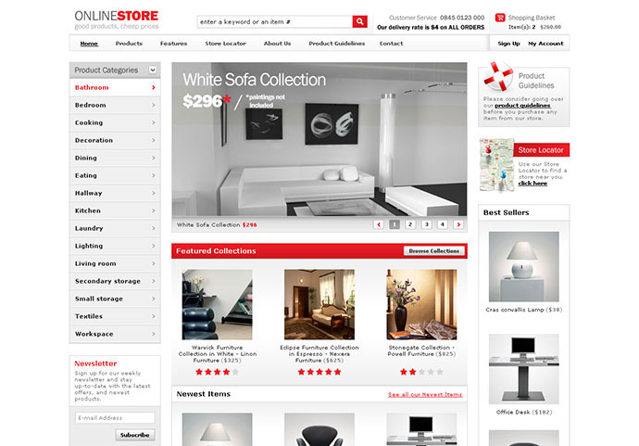

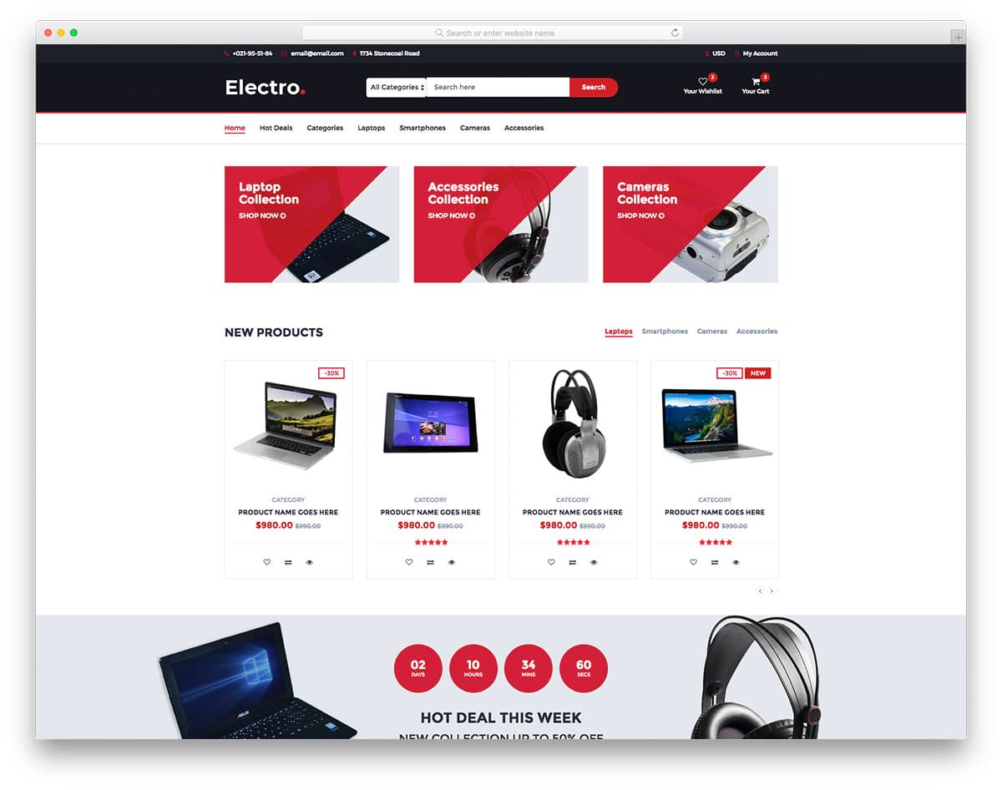

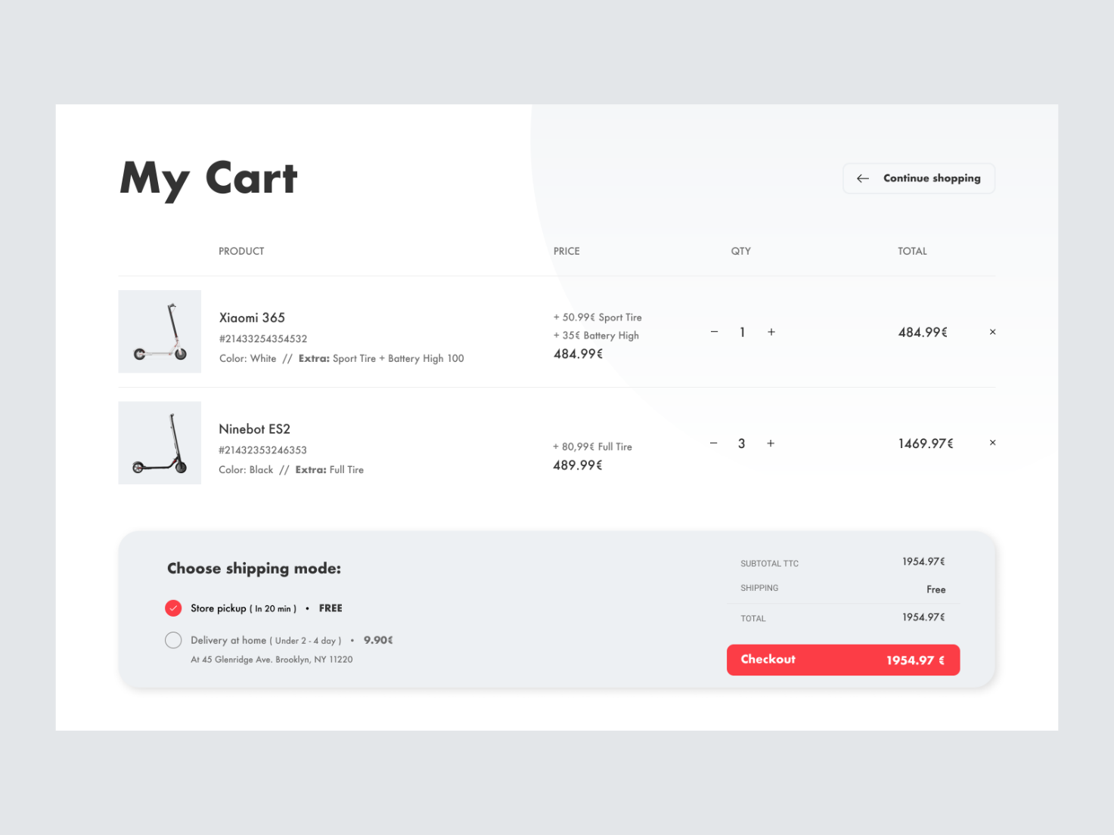

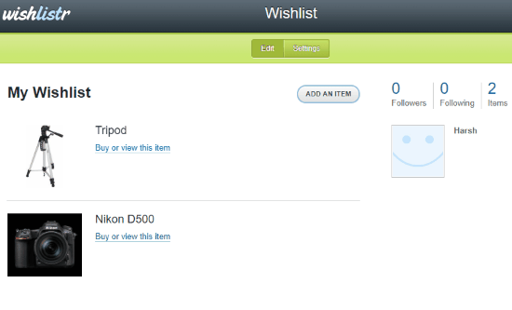

**CHAPTER-5**

**REPORT**

**5.1 ScreenShots**

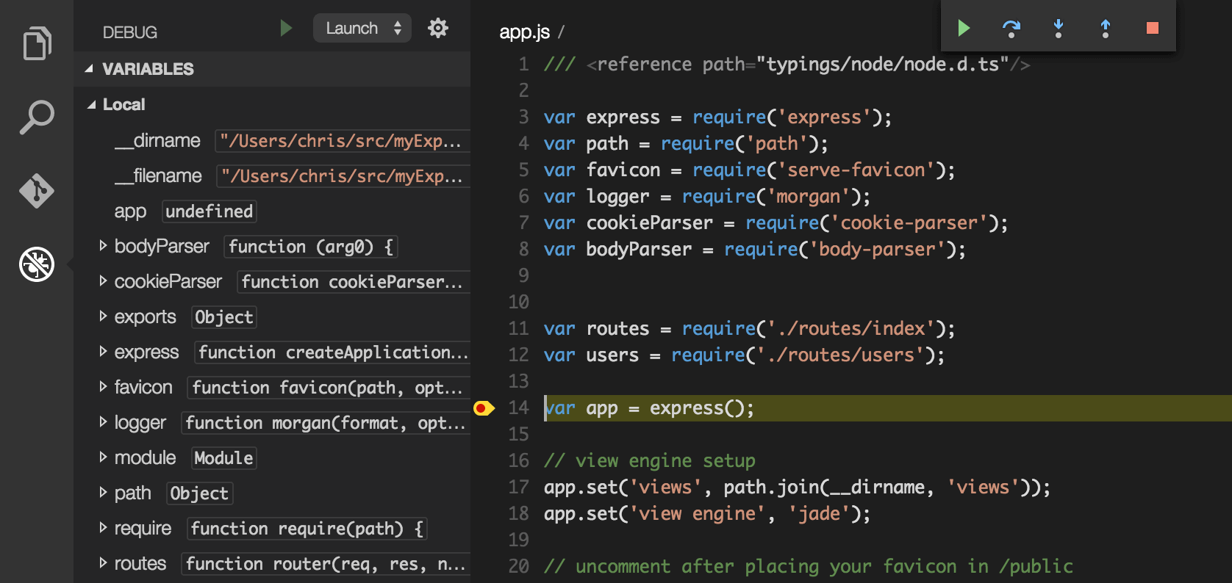



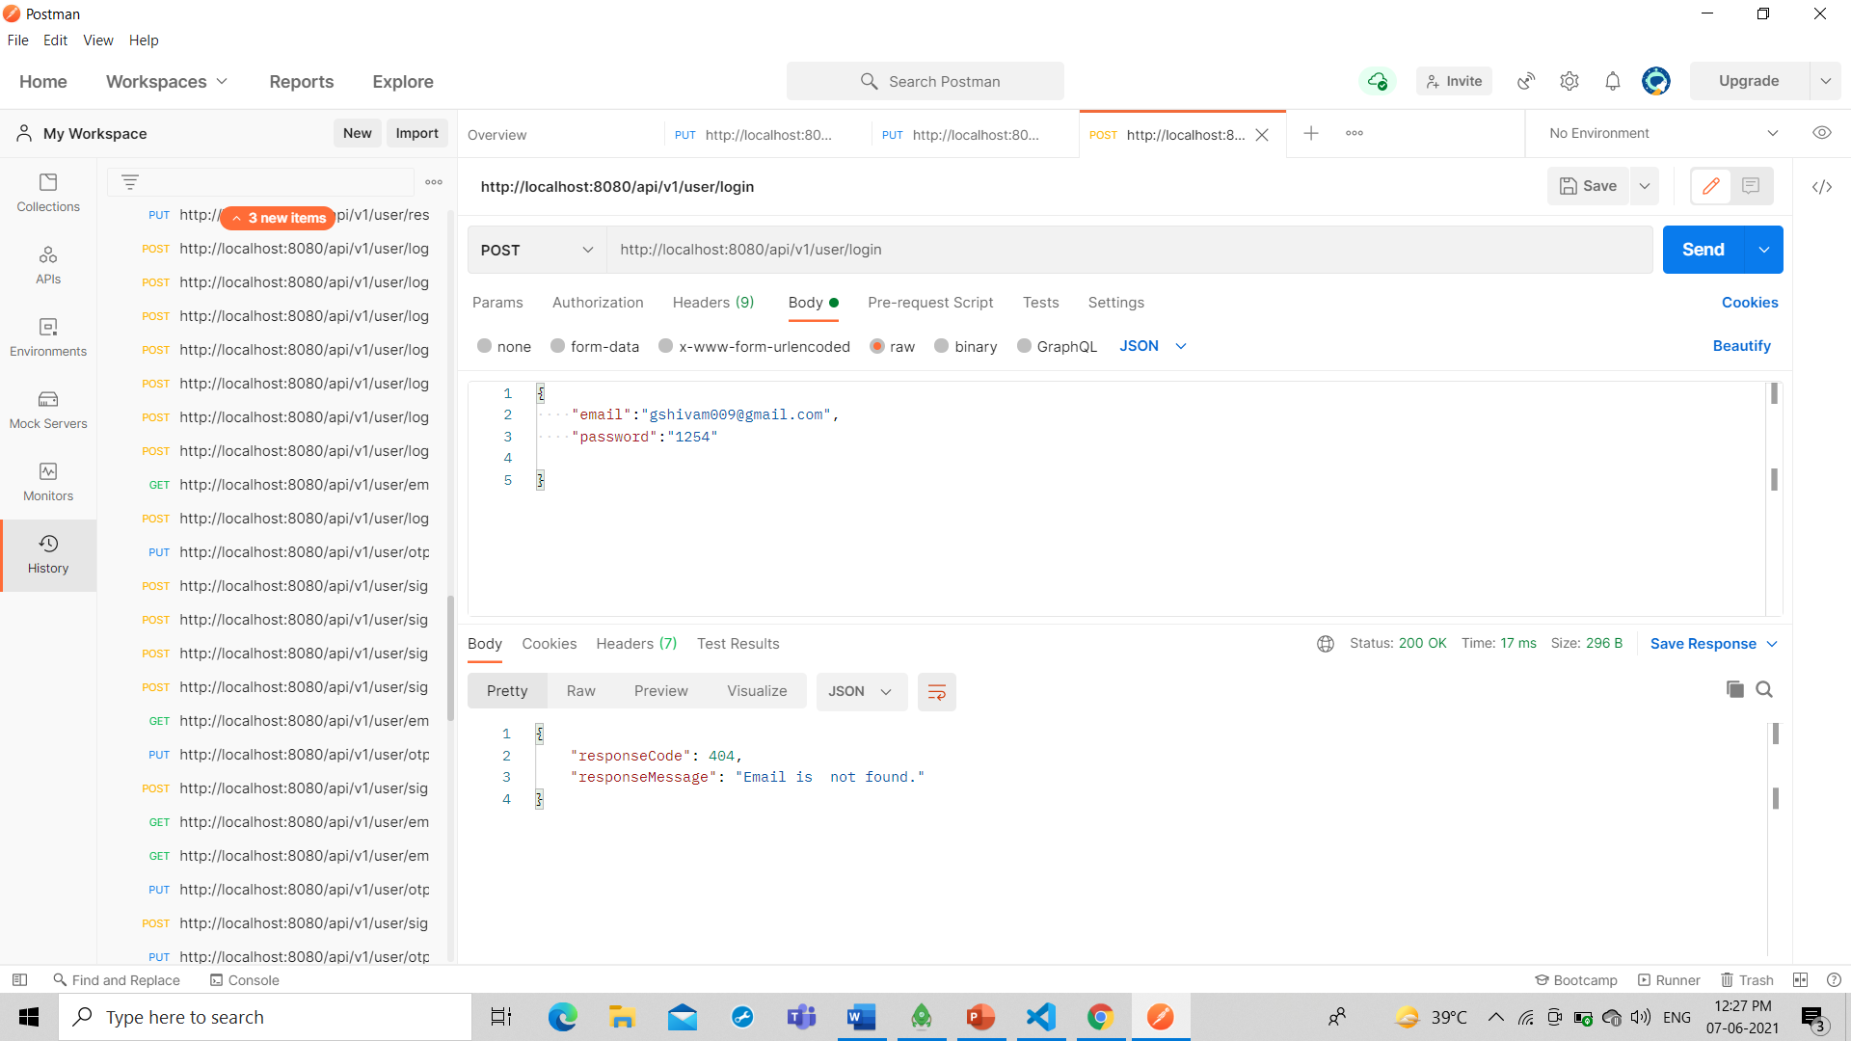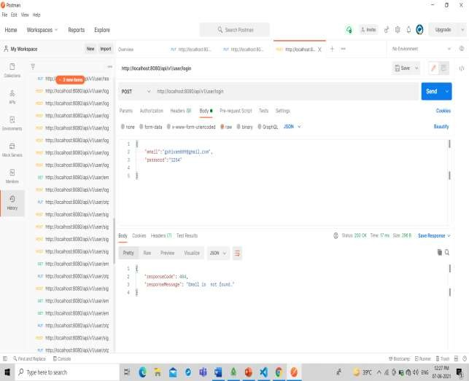



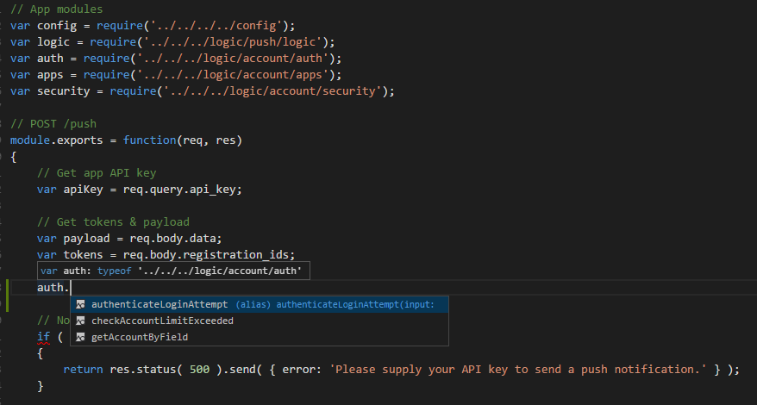

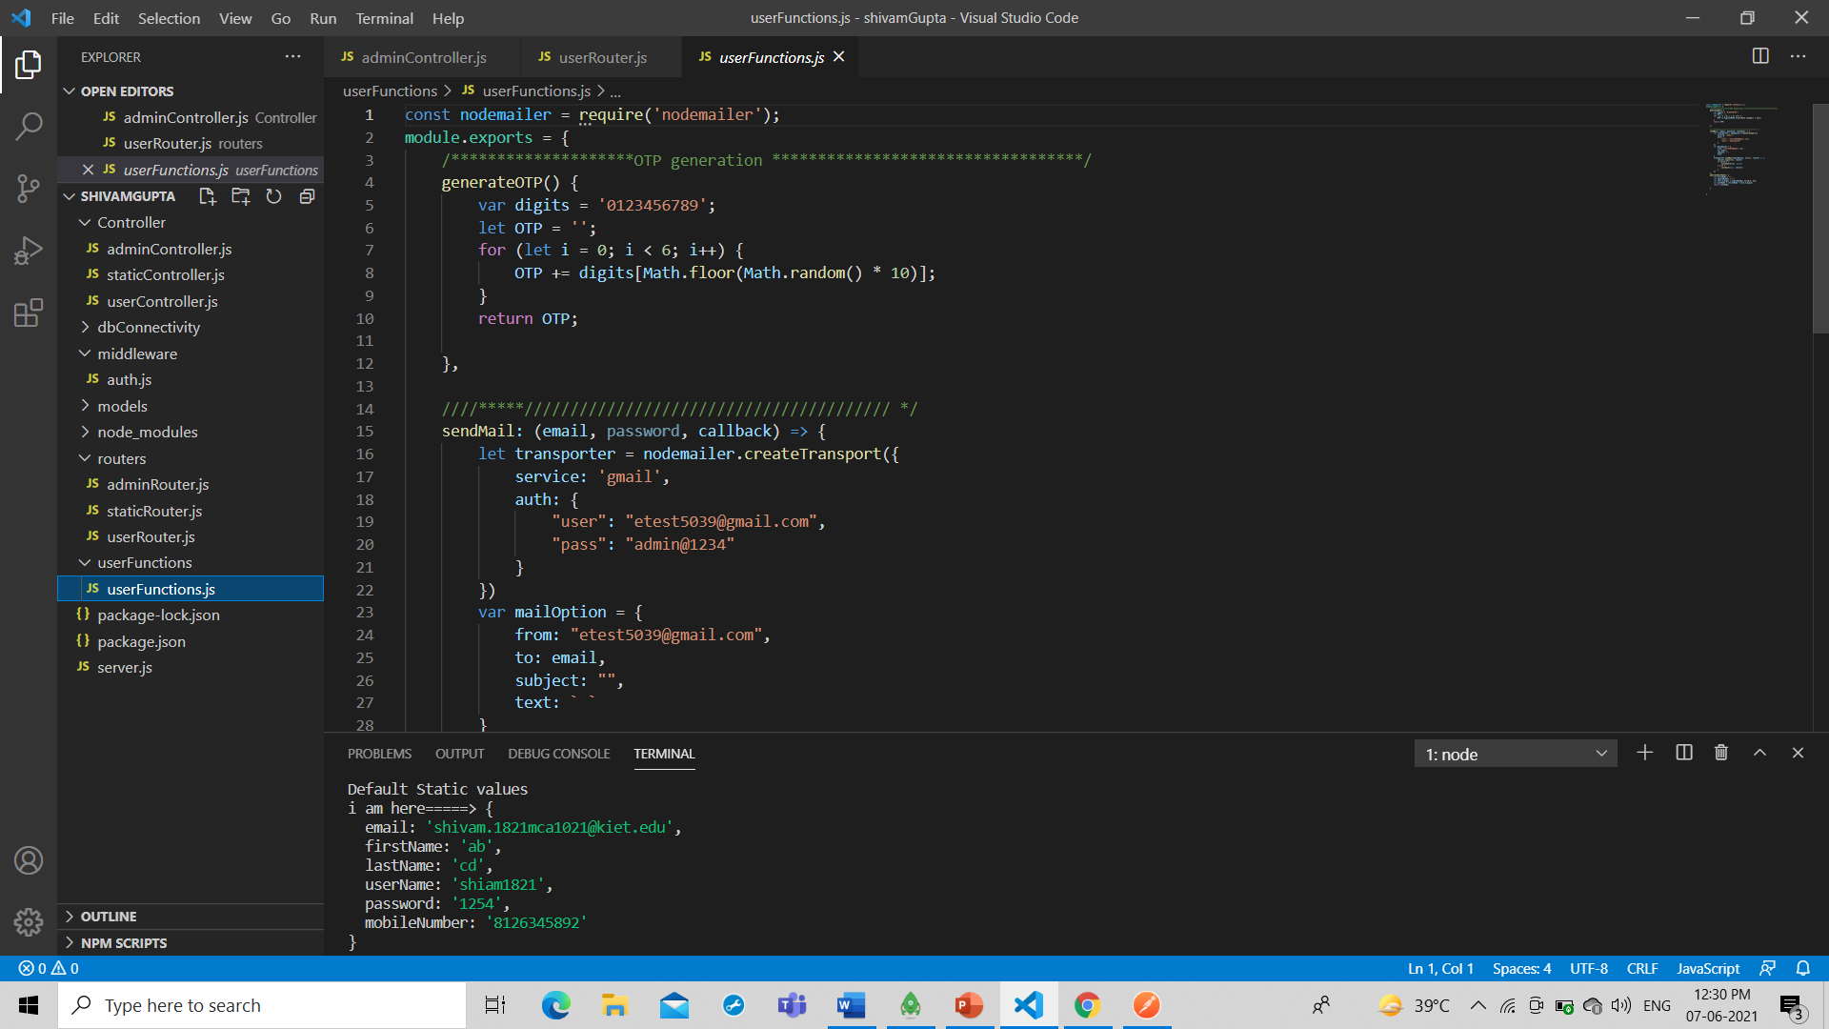

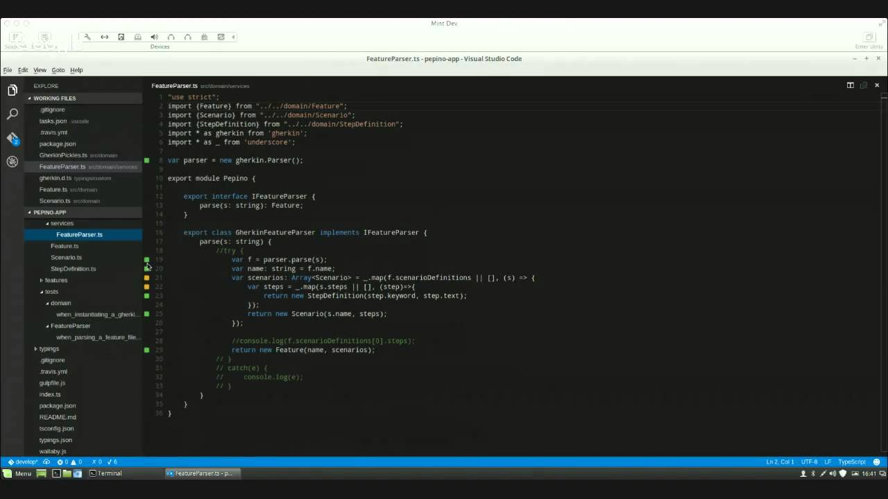

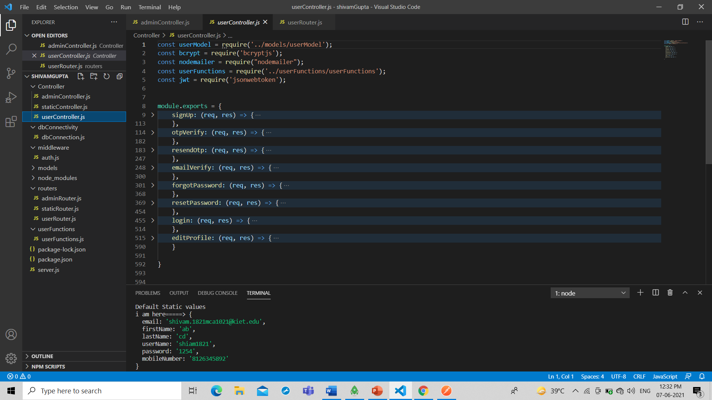

6.1 Test Cases for Login Page

**CHAPTER-6**

**TESTING**

* Verify that all the labels and controls including text-boxes, buttons, and links are present on the Login page.
* Check that the font type and size of the labels and the text written on the different elements should be clearly visible.
* Verify that the size, color, and UI of the different elements are as per the specifications.
* Verify that the application’s UI is responsive i.e. it should adjust to different screen resolutions and devices.

6.2 Functional Test Scenarios for Login Page

* Verify that as soon as the login page opens, by default the cursor should remain on the username textbox.
* Verify that the user is able to navigate or access the different controls by pressing the ‘Tab’ key on the keyboard.
* Check if the password is in masked form when typed in the password field.
* Check if the password can be copy-pasted or not.
* Verify that the user is able to login by entering valid credentials andclicking on the ‘Login’ button.
* Verify that the user is able to login by entering valid credentials and pressing Enter key.
* Check that the user is not able to login with an invalid username and password.
* Verify that the validation message gets displayed in case the user leaves the username or password field as blank.
* Check that the validation message is displayed in the case the user exceeds the character limit of the user name and password fields.
* Verify that reset button functionality on the login page. Clicking on it
* should clear the textbox’s content.
* Verify if there is a checkbox with the label “remember password” on the login page.
* Verify that closing the browser should not log-out an authenticated user. Launching the application should lead the user to login state only

6.3 Security Test Cases for Login Page

* Verify that there is a limit on the total number of unsuccessful login attempts. So that a user cannot use a brute-force mechanism to try all possible combinations of username-password.
* Verify that in case of incorrect credentials, a message like “incorrect
* username or password” should get displayed. Instead of an exact message pointing to the incorrect field. This is because a message like “incorrect password” will help a hacker in knowing that the username is correct. In this way, he will just need to try a different combination on the password field only.
* Verify the login session timeout duration. So, that once logged-in a user cannot be authenticated for a life-time.
* Verify that once logged in, clicking the back button doesn’t logout the user.
* Verify if SQL Injection attacks work on the login page. The application should not be vulnerable to SQL injection attacks.
* Verify that XSS vulnerability should not work on the login page

6.4 General Test Cases for Ecommerce Application

* + - Verify that all the links and banners are redirecting to correct product/category pages and none of the links are broken.
    - Verify that the company logo is clearly visible.
    - Verify that all the text – product, category name, price, and product description are clearly visible.
    - Verify that all the images – product and banner are clearly visible.
    - Verify that category pages have a relevant product listed specific to the category.
    - Verify that the correct count of total products is listed on the category pages.
    - Search – Verify that on searching all the product satisfying the search criteria are visible on the search result page.
    - Search – Verify the more relevant product for the search term is displayed on the top for a particular search term.
    - Search – Verify that count of products is correctly displayed on the search result page for a particular search term.
    - Filtering – Verify that filtering functionality correctly filters products based on the filter applied.
    - Filtering – Verify that filtering works correctly on category pages.
    - Filtering – Verify that filtering works correctly on the search result page.
    - Filtering – Verify that the correct count of total products is displayed after a filter is applied.
    - Sorting – Verify that sorting works correctly on the category pages.
    - Sorting – Verify that sorting works correctly on the search result page.
    - Sorting – Verify that sorting works correctly on the pages containing the filtered result, after applying filters.

6.5 Product Buy Flow – Test cases for Ecommerce Website

* + - Verify that on the product page, the user can select the desired attribute of the product e.g. size, color, etc.
    - Verify that the user can add to cart one or more products.
    - Verify that users can add products to the wishlist.
    - Verify that the user can buy products added to the cart after signing in to the application (or as per the functionality of the website).
    - Verify that the user can successfully buy more than one product that was added to his/her cart.
    - Verify that the user cannot add more than the available inventory of the product.
    - Verify that the limit to the number of products a user can by is working correctly by displaying an error message and preventing the user from buying more than the limit.
    - Verify that the delivery can be declined for the places where shipping is not available.
    - Verify that the Cash on Delivery option of payment is working fine.
    - Verify that the different pre-paid methods of payments are working fine.
    - Verify that product return functionality works fine.

#### 6.6 Seller – Product creation Test case

* Verify that authenticated sellers get access to product creation panels specific to the authorized categories.
* Verify that the product creation panel is working fine for single product creation.
* Verify that the product creation panel is working fine for multiple product creation.
* Verify that the maximum product creation limit for the seller is working fine, limiting the seller to create more than the desired number of products.
* Verify panel validation for checking mandatory fields.
* Verify that duplicate product creation is restricted through the panel.

6.7 User(Buyer) Registration – Test cases

* + - Verify that all the specified fields are present on the registration page.
    - Verify that the required/mandatory fields are marked with * against the field.
    - Verify that for better user interface dropdowns, radio buttons and checkboxes, etc fields are displayed wherever possible instead of just textboxes
    - Verify the page has both submit and cancel/reset buttons at the end.
    - Verify that clicking submits button after entering all the required fields, submits the data to the server.
    - Verify that clicking cancels/reset button after entering all the required fields, cancels the submit request, and reset all the fields.
    - Verify that whenever possible validation should take place at client side
    - Verify that not filling the mandatory fields and clicking the submit button will lead to validation error.
    - Verify that not filling the optional fields and clicking the submit button will still send data to the server without any validation error.
    - Check the upper limit of the textboxes.
    - Check validation on the date and email fields (only valid dates and valid email Ids should be allowed.
    - Check validation on numeric fields by entering alphabets and special characters.
    - Verify that leading and trailing spaces are trimmed.
    - Verify that entering blank spaces on mandatory fields leads to validation error.
    - Verify that after making a request to the server and then sending the same request again with the same unique key will lead to server-side validation error.

CHAPTER-7

LIMITATIONS

##### 7.1 The Top disadvantages and limitations for e-Commerce businesses:

* + - **Security:** One of the main limitations of eCommerce is security. In most cases, people are hesitant to provide their personal and financial details in spite of advanced data encryption security systems in place. Moreover, there are some websites that do not have the capability and features installed to authenticate transactions. As such, there are instances of [fraudulent activities](https://www.shiprocket.in/blog/ecommerce-online-scamming-fraudsters-countries/). The fear of providing financial information like credit card details hinders

the [growth of eCommerce](https://360.shiprocket.in/blog/ecommerce-growth-india-market-research-stats/).

* + - **Lack of Privacy:** To some extent, the privacy of a customer is compromised in eCommerce. You need to provide your personal details, such as an address, telephone number, and so on to the seller. There are still lots of sites that do not have the advanced technology to protect sensitive information. Moreover, there are also sites that illegally collect consumer statistics without permission. This is one reason why people get skeptical while using eCommerce.
    - **Tax Issue:** In the case of different geographical locations, sales tax becomes an issue. Many a time sellers have faced problems in the computation of sales tax. Moreover, physical stores have a risk of losing business if online transactions are exempted from taxation.
    - **Fear:** In spite of the popularity, there still resides an element of doubt in the mind of people when it comes to online shopping. This is because the customer cannot physically examine the product and is not sure about the features and attributes. This is why a lot of people prefer shopping from physical stores.
    - **Product Suitability:** As already mentioned, it is not possible for people to physically examine the [product](https://www.shiprocket.in/blog/product-page-optimization/) in eCommerce. In many cases, the original product may not match the picture or specifications in the eCommerce site. This absence of ‘touch and feel’ creates a discouraging effect.
    - **Cultural Obstacles:** As the process of eCommerce encompasses customers across the globe, the habits, traditions, and culture differ. There may also be linguistic problems and all these may lead to issues between the seller and buyer.
    - **High Labour Cost:** In order to get the whole eCommerce and delivery process right, a specialized workforce is required. To get all these in the right shape, companies have to shed a good amount of money and employ a talented pool of people.
    - **Legal Issues:** A lot of legal compliances and cyber laws need to be taken care of in an eCommerce business. These regulations may vary from country to country. All these reasons deter businesses from going electronic.
    - **Technical Limitations:** eCommerce requires advanced technology platforms for better performance. Some limitations, such as lack of proper domain, network and software issues, and so on can affect the seamless performance of an eCommerce site.
    - **Huge Technological Cost:** Last but not the least; a lot of money needs to be invested to be built up the technical infrastructure needed to run an eCommerce business. Moreover, they need to be upgraded based to keep abreast with the changing technology.
    - **Delivery Guarantee**: Many people fear that their product might not be [shipped](http://www.shiprocket.in/) or the website might be a fraud. Businesses need to work to build customer trust with reviews, testimonials, etc. to add more value to their website.

#### 7.2 FUTURE SCOPE & ENHANCEMENT

In the foreseeable future, e-commerce will be confirmed as the major tool of sale for the goods and services. Successful e-commerce will become the notion which will be inseparable from the web because e-shopping is becoming more and more popular and natural. ... Each year, there is a continuous growth in e-commerce deals.

7.3 Future of E-commerce in India

India is developing rapidly towards e-commerce market trends day by day. The internet user base in India might still be mere 300 million which is much less as compared to the other developed countries but its surely expanding day by day. India has third largest internet population after US & China. Indian internet population was 205 millions in 2013 but projected to be second largest by 2016 with 330-370 million users. As per the last three years there is a rapid change in the scenario of ecommerce in India. More than 200 million users has been added during last three years. Growth of internet users is increasing very rapidly in India.

**CHAPTER-8**

**CONCLUSION**

We have successfully implemented the Project’. With the help of various links and tools, we have been able to provide a site which will be live soon and running on the web. We have been successful in our attempt to take care of the needs of both the user as well as the administrator. Finally we hope that this will go a long way in popularizing.

**CHAPTER 9**

**LITERATURE REVIEW**

9.1 Executable HTML

Batalas[1] Executable HTML is a collection of custom HTML elements that offer document authors the ability to write and execute procedural logic in HTML5. We discuss the motivation of this approach, which lies in the composition of formal Ambulatory Assessment protocols for clinical psychology research, and provide an overview of the software’s inner workings.

Khan, V. J[2] This approach is enabled by the execution semantics of xUML and is based on automatic translation from xUML to S/R, the input language of the COSPAN model checker (R.H. Hardin et al., 1996). Model transformations are applied to reduce the state space of the resulting S/R model that is to be verified by COSPAN. An xUML level logic for specifying properties to be checked is defined.

9.2 Programming

Van Rossum[3] Python is an easy to learn, powerful programming language. It has efficient high-level data structures and a simple but effective approach to object-oriented programming. Python’s elegant syntax and dynamic typing, together with its interpreted nature, make it an ideal language for scripting and rapid application development in many areas on most platforms

Zelle[4] The Python interpreter and the extensive standard library are freely available in source or binary form for all major platforms from the Python Web site, http://www.python.org/, and can be freely distributed. The same site also contains distributions of and pointers to many free third party Python modules, programs and tools, and additional documentation.

9.3 Computing

Herman[5] The discovery of music recording was a transformative event in human history. Here was an invention that almost everyone instantly desired. Recorded music can be enjoyed by people who cannot read or write, who cannot themselves play an instrument or sing. It is hard to look back on the first crude recording technologies with their scratchy noises and wobbly playback and understand how people could be satisfied. An amazing accumulation of clever technology has improved the quality of recording and playback to a remarkable extent. Even in the early days, engineers worked hard to reduce noise and ensure good fidelity in reproducing original sound.

9.4 HTML5

Lawson[5] HTML5 is the latest and most enhanced version of HTML. Technically, HTML is not a programming language, but rather a markup language.

9.5 HTML,CSS, and JavaScript

Fajfar[6] HTML provides the *basic structure* of sites, which is enhanced and modified by other technologies like CSS and JavaScript. CSS is used to control *presentation, formatting, and layout*. JavaScript is used to control the *behavior* of different elements.

9.6 JavaScript for Data Science

Gans, M[7] JavaScript is well-known for its abilities in web-development, but how would those abilities carry over into an application in Data Science? First and foremost, we should consider that JavaScript is not a statistical programming language. The language was pretty much created for web-development, which the language excels at. This means that JavaScript from a typical Statistician’s point of view might be a bit hard to grasp.

9.7 Software Engineering

Al-Sarayreh[9] Software engineering, a fairly recent engineering discipline, is still evolving without a wide consensus on a body of fundamental principles as in traditional engineering fields with their own long-established principles originating from physics, chemistry and mathematics. This paper reports on a [systematic mapping study](https://www.sciencedirect.com/topics/computer-science/systematic-mapping-study) (SMS) that identified 30 papers and books from 1969 to January 2020, each proposing their own sets of software engineering principles (SEP). Within these studies a total of 592 SEP were proposed, these studies were reviewed and classified on the basis of four mapping questions examining publication trends, use of explicit criteria for the proposed SEP.

Pawlak[10] There are many existing solutions which have different benefits and issues. The most significant ones are lack of transparency and auditability. Recently developed blockchain technology may be a solution to these issues. The paper describes the use of intelligent agents and multi-agent system concept for Auditable Blockchain Voting System (ABVS), which integrates e-voting process with blockchain technology into one supervised non-remote internet voting system which is end-to-end verifiable.

#### CHAPTER-10

#### REFRENCES

1. Strykowski, Sergiusz, and Wojciech Cellary. "Deploying the E-Commerce Application System in Wholesale Commerce." BIS 2000. Springer, London, 2000. 211-217.
2. Strykowski, S., & Cellary, W. (2000). Deploying the E-Commerce Application System in Wholesale Commerce. In BIS 2000 (pp. 211-217). Springer, London.
3. Strykowski, Sergiusz, and Wojciech Cellary. "Deploying the E-Commerce Application System." BIS 2000: 4th International Conference on Business Information Systems, Pozna?, Poland, 12–13 April 2000. Springer, 2000.
4. Strykowski, S., & Cellary, W. (2000, March). Deploying the E-Commerce Application System. In BIS 2000: 4th International Conference on Business Information Systems, Pozna?, Poland, 12–13 April 2000 (p. 211). Springer.
5. Zhang, Liyi, Yan Tang, and Jian Meng. "EIRS: An Intelligent E-Commerce Application System for Small Retailers in China." Research and Practical Issues of Enterprise Information Systems II. Springer, Boston, MA, 2008. 917-921.
6. Zhang, L., Tang, Y., & Meng, J. (2008). EIRS: An Intelligent E-Commerce Application System for Small Retailers in China. In Research and Practical Issues of Enterprise Information Systems II (pp. 917-921). Springer, Boston, MA.
7. Zhang, Liyi, Yan Tang, and Jian Meng. "EIRS: An Intelligent E-Commerce Application System for Small Retailers in China." In Research and Practical Issues of Enterprise Information Systems II, pp. 917-921. Springer, Boston, MA, 2008.
8. Li, Qing. "Evaluation modeling on E-commerce Application of Enterprise." Recent Advances in Computer Science and Information Engineering. Springer, Berlin, Heidelberg, 2012. 101-108.
9. Li, Q. (2012). Evaluation modeling on E-commerce Application of Enterprise. In Recent Advances in Computer Science and Information Engineering (pp. 101-108). Springer, Berlin, Heidelberg.
10. Li Q. Evaluation Modeling on E-Commerce Application of Enterprise. Recent Advances in Computer Science and Information Engineering: Volume 4. 2012 Feb 10;127:101.